Workout Worksheet

Directions: circle or indicate two of your favorite examples in each of the lists below. Then use these to help you create your activity log.

Warm up / Cool Down
Jump Rope | Stretching | Jogging | Jumping Jacks | Walking

Aerobic Capacity
Bicycling | Swimming | Jogging | Aerobic video/class | Dancing

Muscular Strength
Push-ups | Squats | Burpees | Sit ups | Triceps dips

Muscular Endurance
Curl ups | Wall sits | Plank | Yoga Poses

Flexibility
Static
Calf stretch | Triceps stretches | Hamstring stretches | Quadriceps stretches

Dynamic
High knees | Butt kicks | Arm circles | Leg swings

Personal Fitness Log

Fitness Component | Monday | Tuesday | Wednesday | Thursday | Friday | Saturday | Sunday
Muscular Strength
Muscular Endurance
Flexibility
Aerobic Capacity

FITT Principle

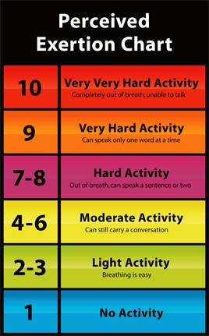
Definition of FITT Principle

F = Frequency. Describes how often activity takes place in a week.
I = Intensity. Describes how vigorous the participant is engaged in activity.
T = Type. Describes the specific activity selected.
T = Time. Describes how long the participant is engaged in activity.

Directions: Look at your activity log and using ONE of the components fill in the following:
Component
Frequency

(how many times during the week do you plan to exercise targeting this component)
Intensity

(Using the Perceived Exertion Chart what do you plan for your intensity level)
Time

(How much TOTAL time during the week do you plan to exercise targeting this component)
Type

(What different type of exercises do you plan to do targeting this component)

Overload and Progression

Definition of Overload
Overload is the amount of resistance or distance run/walk in a workout to provide a greater stress on the body than it is normally used to in order to increase fitness.

Definition of Progression
Progression is the way a person should increase the workout (weight lifted or distance run/walk). It is a gradual increase either in frequency, intensity, or time or a combination of all three components.

Directions: Using the component that you chose for the F.I.T.T table on the page above describe in 2 sentences an example of how you would use overload and progression to improve your fitness for this area.

Overload ______________________________________________________________________________ ______________________________________________________________________________ ______________________________________________________________________________ ______________________________________________________________________________

Progression
______________________________________________________________________________ ______________________________________________________________________________ ______________________________________________________________________________ ______________________________________________________________________________

