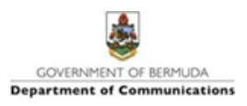

**PRESS RELEASE**

**25  April 2021**

**Ministry of Education Awards and Scholarships Update**

The Minister of Education, the Hon. Diallo Rabain, JP, MP, has this afternoon released the following statement to provide the public with an update on the Ministry of Education Awards and Scholarships.

Minister Rabain stated, “The Ministry of Education has been informed that the Bermuda Scholarships website [www.bermudascholarships.com](http://www.bermudascholarships.com/) is temporarily offline. Students applying for Ministry awards and scholarships are advised that the website is being worked on and should be back operational shortly. However, to ensure that all students interested can successfully submit their application, the deadline for filing applications for the Ministry’s awards and scholarships will be extended to 4:45 pm on Wednesday, April 28th, 2021.”

In closing Minister Rabain shared, “Each of us has a role to play in stopping the spread of the coronavirus. Follow Public Health guidelines, wear a mask, practice good hand hygiene, maintain physical distance and download the WeHealth Bermuda app. Do the research, talk with your doctor, and make an informed decision about getting the COVID-19 vaccine.”