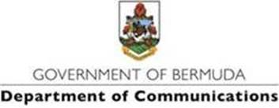

**6 April 2022**

**UPDATE: The Annual Middle and Senior School Art Exhibition Opens on April 8th, 2022**

**The public is advised of a change of date:**

The Annual Middle and Senior School Art Exhibition will begin on Friday, April 8th, 2022.

The opening ceremony will be on Friday, April 8th from 5:30pm – 7:30pm and the exhibition will be open and free to the public from Friday, April 9th – April 26th.

The 56th Annual Art Exhibition is open at the Bermuda Society of Arts gallery at the City Hall. After two years of virtual art displays, the public can explore the exhibition and appreciate these beautiful works in person.

The works are vibrant, thought-provoking, and engaging as students visually answer the question, “Is Bermuda Another World?’

The exhibition will feature works from the public and private middle and senior schools. Visitors to the exhibit are encouraged to vote for their favourite piece and artist. Students will be awarded “People’s Choice Awards”.

The admission is free on weekdays from10:00 am – 4:00 pm, and Saturdays from 10:00 am – 4:00 pm. Come, visit and support the student artists in your school at this years’ Arts Exhibition 2022.